|  |  |  |  |
| --- | --- | --- | --- |
| 症状原名 | 翻译 | 备注 | 症状的简介 |
| #表示复合症状名字，红色表示属于复合症状的子症状  特殊性症状蓝色标识  可能有问题需要合并症状的用橙色标识 |  | 为了简化些，正反义词我只保留了一个意思  特殊性症状（即只有一个量表出现的症状）则参考或选用量表英文原版题目 | Eiko的补充材料中有这个东西，咱们后续可以也加进来，是对症状的简单说明。 |
| 抑郁情绪# | Depressed mood |  |  |
| 忧郁 | Blue |  |  |
| 情绪低沉/容易高兴 | Low mood |  |  |
| 悲哀 | Sad |  |  |
| 痛苦(不开心) | Pain |  |  |
| 精神性焦虑 | Psychic anxiety |  |  |
| 激越 | Agitation |  |  |
| 躯体性焦虑*** | Somatic anxiety |  |  |
| 心理忧虑 | Psychological worry |  |  |
| 躯体忧虑 | Somatic worry |  |  |
| Diurnal variation昼夜情绪变化 | Diurnal variation |  |  |
| 被打扰bothered | Bothered |  |  |
| 害怕 | Fear | 还是用  Panic? |  |
| 易怒# | Irritability |  |  |
| 对家长易怒 | Short-tempered with parents |  |  |
| 幸福感 | Feeling Happy |  |  |
| ﻿  孤独感 | Feeling Lonely |  |  |
| 苦闷感 | Feeling Ademonia |  |  |
| ﻿  失败感/成就感 | Feeling Failure | 可能应该与生活很好/生活一无是处合并 |  |
| 希望/绝望/悲观 | Pessimism/Despair | 希望/绝望/悲观  希望/绝望只留下了绝望  在中文中悲观、绝望几乎都放在一起使用，但是英文悲观跟绝望可能使用场景与中文不一致因此是悲观/绝望  写的时候应该额外解释 |  |
| 压抑感 |  | 此症状出自CES-D第6题有翻译为  6我感到压抑。  亦有翻译为  我感到消沉  但英文题目为  I felt depressed.  因此建议将其归类至抑郁情绪，并删除此症状 |  |
| 自责/内疚 | Guilty/Self-accusation | 写的时候也应该额外解释内疚自责在中文中的使用情况 |  |
| 自卑/自信# | Self-abasement | Hamd的中文翻译认为自卑和无价值是一个意思需要合并吗？ |  |
| 心理自卑 |  | 包括讨厌自己、自我憎恨、自我嫌弃、自我贬低等等 |  |
| ﻿  负性体像 |  | CDI的英文原题是I look ugly |  |
| 没人爱自己 | People disliked me |  |  |
| 无价值感 | Worthlessness |  |  |
| 生活很好/生活一无是处 | Past failure | 此症状来自CES-D 为Q4Q9的合并Q4为 I felt that I was just as good as other people.  Q9为I thought my life had been a failure.  Eiko的症状中有一个Past failure 应该比较符合  且此症状应该可以与失败感合并 |  |
| 能力减退感 | Ability loss |  |  |
| Energy loss 能量丧失/精力不足/能量增加 | Energy loss |  |  |
| 性欲减退 | Decreased libido |  |  |
| 兴趣/乐趣减退# | Interest/ Pleasure loss |  |  |
| 兴趣减退 | Interest loss |  |  |
| 乐趣减退 | Pleasure loss |  |  |
| 思考困难 | Difficulty in thinking |  |  |
| 走路慢/无法继续日常工作*歧义 | I could not get “going” |  |  |
| 言语减少 | Talked less |  |  |
| 迟缓 | Retardation |  |  |
| 躯体症状# | Somatization |  |  |
| Gastrointestinal 肠胃(便秘，腹泻） | Gastrointestinal |  |  |
| 交感神经兴奋（心悸、震颤、耳鸣、胸痛） | Sympathetic arousal |  |  |
| 躯体疾病（疼痛、头痛、四肢沉重） | General somatic symptoms |  |  |
| 疲惫感 | Fatigue |  |  |
| 食欲变化# | Appetite Change |  |  |
| Appetite increase 食欲增加 | Appetite increase |  |  |
| Appetite decreas 食欲降低 | Appetite decreas |  |  |
| 睡眠障碍# | Somnipathy |  |  |
| 睡眠质量差 | Poor sleep |  |  |
| Hypersomnia 嗜睡 | Hypersomnia |  |  |
| 前期失眠 | Early insomnia |  |  |
| 中期失眠 | Middle insomnia |  |  |
| 末期失眠 | Late insomnia |  |  |
| 体重减轻 | Weight decrease |  |  |
| 社交减少# | Less socialize |  |  |
| 不想见朋友 | I didn’t want to see my friends. |  |  |
| 冷淡 | Unconcern |  |  |
| 缺乏朋友 | Lack of friends | CDI原题为I do not have any friends. |  |
| 敌意感 | People were unfriendly | 敌意感跟人们对我不友好应该可以合并，是翻译问题  敌意感是CES-D儿童版的题目  英文是1 felt like kids I knew were not friendly or that they didn't want to be with me  人们对我不友好是CES-D 的题目，其英文原题目为People were unfriendly |  |
| 人们对我不友好 |  |  |  |
| 强迫 | Obsessional symptoms | HAMD中文问卷提供了英文的备注 |  |
| 完美主义 | Perfectionism |  |  |
| 丧失自知力 | Loss of insight |  |  |
| 人格解体或现实解体（指非真实感或虚无妄想） | Depersonalization & derealization | HAMD中文问卷提供了英文的备注 |  |
| 疑病 | Hypochondriasis | HAMD中文问卷提供了英文的备注 |  |
| 偏执 | Paranoid symptoms | HAMD中文问卷提供了英文的备注 |  |
| 多疑 | Oversensitive |  |  |
| 被害妄想 | Persecutory delusion |  |  |
| 被惩罚感 | Feeling punished | 出自BDI  I don't feel I am being punished.  I feel I may be punished.  I expect to be punished.  I feel I am being punished. |  |
| 怕自己想坏念头或做坏事 |  | 出自CBCL没找到英文原版 |  |
| 不良行为*歧义 | I am bad all the time. | CDI的英文原题 |  |
| 不顺从 | I never do what I'm told. | CDI的英文原题 |  |
| 争吵 | I get into fights all the time. | CDI的英文原题 |  |
| 讨厌学校 | I never have fun at school. | CDI的英文原题 |  |
| 对学校各种活动没有兴趣 | No interest in school activities |  |  |
| 学习相关 | Learning problems |  |  |
| 离家出走 | Away from home | DSRSC的英文原题为I feel like running away |  |
| 喜欢与家人交谈 | I like talking with my family | DSRSC的英文原题 |  |
| 家庭没有我更好 | I thought my family would be better off without me. | MFQ-C的英文原题 |  |
| 犹豫不决 | Indecisiveness |  |  |
| Concentration 注意力 | Concentration |  |  |
| 易尴尬 | Easily embarrassed |  |  |
| 自杀意念/自杀 | Suicidal ideation |  |  |
|  |  |  |  |

BDI I 题目来源心理卫生评定量表手册

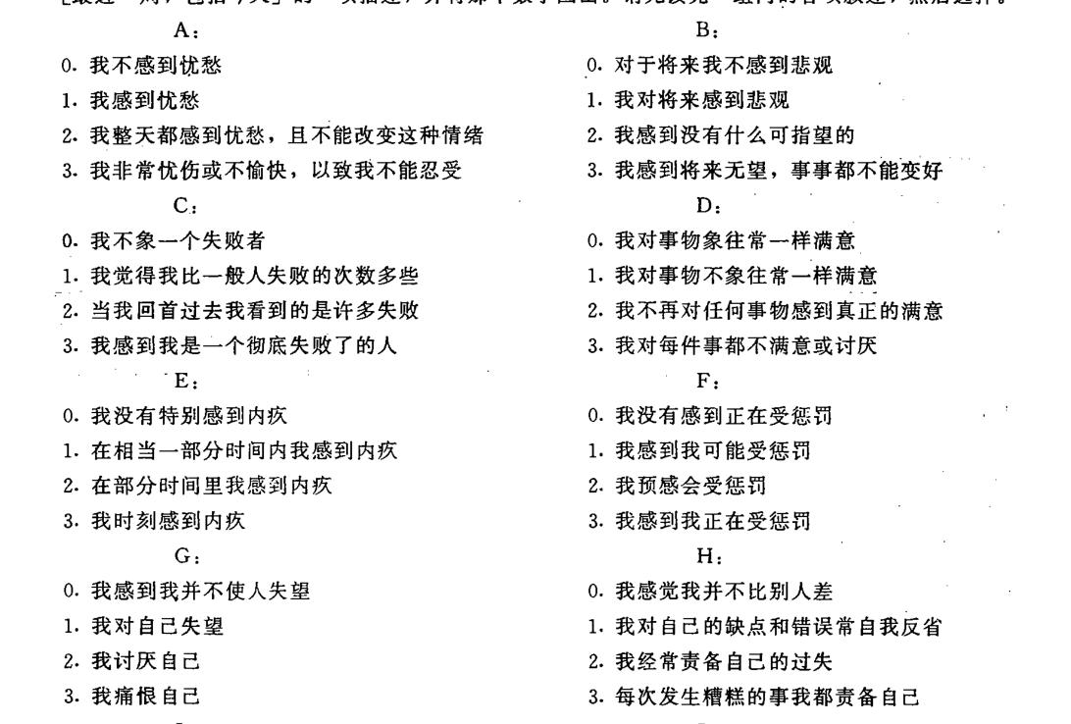 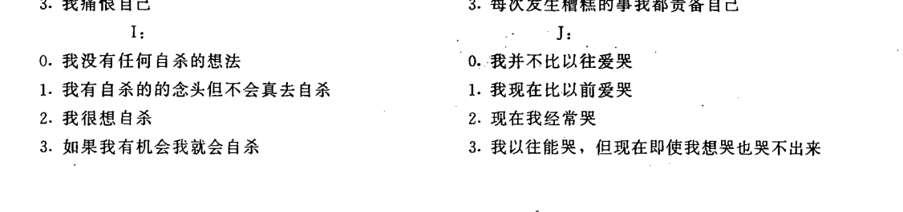 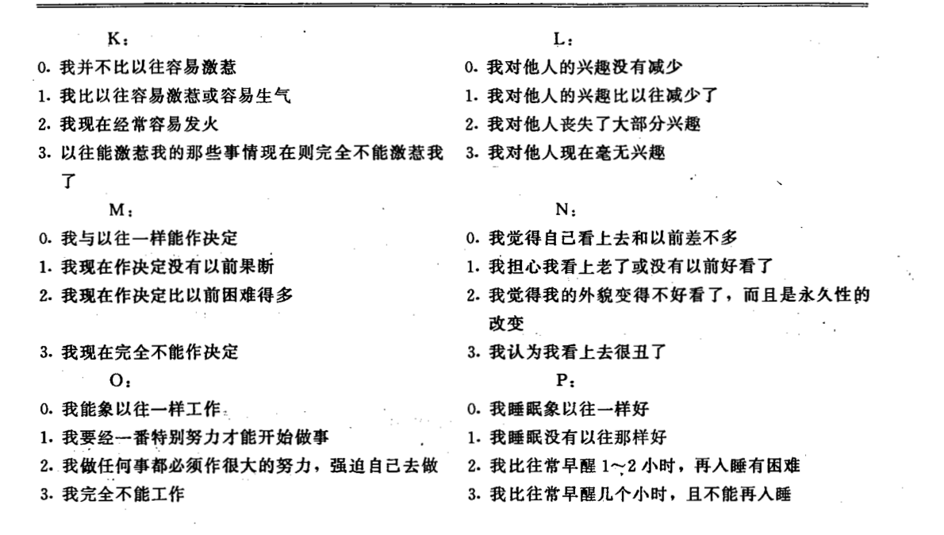 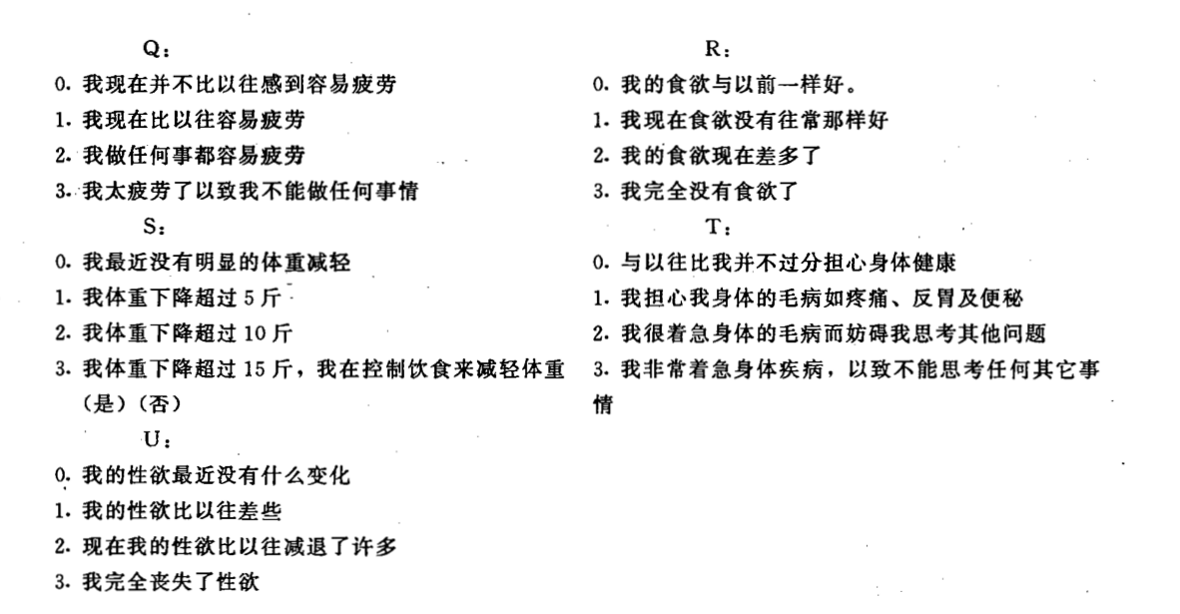

参考咱们之前的结果 不能确定的用红色标记

1为心理忧虑

2为希望/绝望/悲观

3为失败感

4不确定

5为自责/内疚

6为被惩罚感

7为心理自卑

8为自责/内疚

9为自杀意念/自杀

10为哭

11为易怒

12为兴趣减退

13为犹豫不决

14为负性体像

15为Energy loss 能量丧失/精力不足/能量增加 不太确定

16 为睡眠障碍

17为疲惫感

18为食欲变化

19为体重减轻

20为躯体忧虑

21 为性欲减退